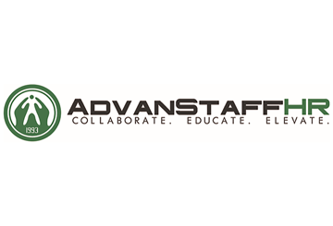
Provided by: AdvanStaff HR

Table of Contents
Introduction 4
Return-to-Work at a Glance 5
COVID-19 Return-to-Work Plans 5
Other Return-to-Work Considerations 7
COVID-19 Vaccine Overview 8
COVID-19 Vaccines and the Workplace 11
Government Guidance Related to COVID-19 Vaccines and Workplaces 11
OSHA Perspective 11
EEOC Perspective 11
Deciding Between a Mandatory or Voluntary Vaccination Policy 13
General Employer Considerations 13
The Case for Mandatory Workplace Vaccination 14
The Case for Voluntary Workplace Vaccination 14
Developing a Workplace Vaccination Plan 16
Step 1: Gauge the Situation 16
Step 2: Make the Choice 16
Step 3: Consider Incentives 16
Step 4: Ensure Resources Are in Place 16
Step 5: Communicate Everything to Employees 16
Step 6: Implement the Plan 17
COVID-19 Vaccines and Workplace Laws 17
Medical Examinations and Vaccine Administration 17
Prescreening Vaccination Questions 17
COVID-19 Vaccination Verification and Disability-related Inquiries 19
Emergency Use Authorization (EUA) and the COVID-19 Vaccine 19
Employees with Disabilities Preventing Vaccination 19
Sincere Religious Beliefs Preventing Vaccination 22

No Reasonable Accommodation Available 22
Genetic Information, Employment Decision-making and Vaccinations 22
Appendix 24
Mandatory COVID-19 Vaccination Policy 25
Voluntary COVID-19 Vaccination Policy 26
Mandatory COVID-19 Vaccination Letter to Employees 27
Voluntary COVID-19 Vaccination Letter to Employees 28
COVID-19 Vaccination Employee Letter for Essential Workers 29
Employer Will Cover the Cost of COVID-19 Testing Letter 30
Welcome Back to Work - Employee Communications Letter 31
COVID-19 Symptom Screening Checklist 32
COVID-19 Vaccine Workplace Planning Checklist 34
Responding to a Positive COVID-19 Test Checklist 37
Return-to-Work Communications Planning Checklist 40
Workplace Reopening Decision Infographic 43
COVID-19 Vaccination: What to Expect Handout 44
Identifying Misinformation About COVID-19 Vaccines - Infographic 46
Three Ways to Avoid COVID-19 Vaccine Scams 47
Building Confidence in COVID-19 Vaccines - Infographic 48
What You Need to Know About the COVID-19 Vaccines - Infographic 49
COVID-19 Vaccine Myths - Infographic 50
Continuing the Journey of a COVID-19 Vaccine - Poster 51
How to Wear a Face Covering Poster 52

Introduction
The COVID-19 pandemic has been raging for months. In that time, many businesses have ceased operations out of safety concerns and have waited for the right opportunity to resume. Now, with COVID-19 vaccines becoming available, employers can finally start planning for their immediate futures.
There are still many unknowns related to the COVID-19 vaccines, but there is at least one agreed-upon factor: Vaccinating employees is the best way to reopen a business safely. However, while it may be the best tool in the arsenal, it is not the only one. Employers will still need to continue using safeguards such as masks and social distancing to ensure the safety of their workers and customers.
With that in mind, this toolkit explores the COVID-19 vaccines and other workplace safeguards, and helps employers decide whether a vaccination policy is right for their organizations. Included at the end is a robust appendix with printable resources that employers can use right now, including policies, communications and more.
As always, AdvanStaff HR will be here to answer any questions related to this toolkit and other workplace matters.

Return-to-Work at a Glance
There are many benefits of return-to-work plans for both employers and employees. Employers can enjoy increased employee engagement, proactive cost containment, reduced turnover, increased communication and improved morale with an established return-to-work plan. And it’s been proven that employees who go through return-to-work plans are able to get back to work quicker than those who don’t, meaning that employers will see increased productivity following an employee’s return to work.
Employees also benefit from return-to-work plans, as they feel supported by their employer, which increases their engagement and loyalty to the company. Utilizing a return-to-work plan also helps them get back to work faster and increases the likelihood that they feel secure and stable in their role.
The benefits of return-to-work plans are undeniable. While these plans are typically customized on an individual basis, employers can use the basics of a return-to-work plan to build their company’s methodology for getting employees to return to work following the COVID-19 pandemic.

COVID-19 Return-to-Work Plans
COVID-19 has caused many businesses to shut down or transition their employees to work from home, disrupting daily work life for many. As stay-at-home regulations are scaled back and all businesses are allowed to resume as normal, employees will be asked to come back to work. While they may not be coming back from an injury or leave, employers still need to have a plan in place for all employees to safely and successfully return to work. This will be true even after employees are vaccinated against COVID-19, as return-to-work plans will still need to include safeguards such as social distancing and mask-wearing, even if some or all of a workforce is vaccinated.
While employers may need to tailor their COVID-19 return-to-work plans to employees’ specific needs (e.g., child care arrangements, caregiving responsibilities and health issues), having a generalized plan in place can help them safely reopen their businesses.
Employers’ COVID-19 return-to-work plans should consider the following:
- Anticipated return-to-work date—With the uncertainty that COVID-19 has brought, it’s important to give clear information and dates when employees are to return to work whenever possible. Employers should ensure they are flexible with dates, since state and federal guidance can quickly change.
- Disinfecting and cleaning measures—Because COVID-19 can remain on surfaces long after they’ve been touched, it’s important that a business frequently cleans and disinfects its facility. Some best practices include:
  - Cleaning and disinfecting all frequently touched surfaces in the workplace, such as workstations, keyboards, telephones, handrails and doorknobs.
  - Discouraging workers from using other workers’ phones, desks, offices, or other tools and equipment, when possible. If necessary, clean and disinfect them before and after use.
  - Providing disposable wipes so that commonly used surfaces can be wiped down by employees before each use.
- Social distancing protocol—Social distancing is the practice of deliberately increasing the physical space between people to avoid spreading illness. In terms of COVID-19, social distancing best practices for businesses can include:
  - Avoiding gatherings of 10 or more people
  - Instructing workers to maintain at least 6 feet of distance from other people
  - Hosting meetings virtually when possible
  - Limiting the number of people on the job site to essential personnel only
  - Discouraging people from shaking hands
- Employee screening procedures—To keep employees safe, employers should consider conducting screening procedures to identify potentially ill employees before they enter the office. The Equal Employment Opportunity Commission (EEOC) permits employers to measure employees’ body temperatures before allowing them to enter the worksite. Any employee screening should be implemented on a nondiscriminatory basis, and all information gleaned should be treated as confidential medical information under the Americans with Disabilities Act (ADA)—specifically, the identity of workers exhibiting a fever or other COVID-19 symptoms should only be shared with members of company management with a true need to know. Employers should also notify employees that they will be screening them, to avoid any surprises.
- Employee safety training—An employer’s return-to-work plan should include detailed safety training guidance to ensure that all employees understand how they can prevent the spread of COVID-19. A plan should discuss the following safety training topics:
  - Respiratory etiquette and hand hygiene—Businesses should encourage good hygiene to prevent the spread of COVID-19. This can involve:
    - Providing tissues and no-touch disposal receptacles
    - Providing soap and water in the workplace
    - Placing hand sanitizers in multiple locations to encourage hand hygiene
    - Reminding employees to not touch their eyes, nose or mouth
  - Personal protective equipment (PPE)—PPE is equipment worn by individuals to reduce exposure to a hazard, in this case, COVID-19. Businesses should focus on training workers on proper PPE best practices. Employees should understand how to properly put on, take off and care for PPE. Training material should be easy to understand and must be available in the appropriate language and literacy level for all workers.
  - Staying home when sick—Employers should encourage employees to err on the side of caution if they’re not feeling well and stay home when they’re sick or are exhibiting common symptoms of COVID-19 (e.g., fever, cough or shortness of breath).
- Mental health considerations—The COVID-19 pandemic has increased stress levels of employees across the country. It’s important that employers’ return-to-work plans include guidance for managing employee mental health concerns when employees return to work.
- Process for individualized requests—An employer’s return-to-work plan should include information about how employees can go about making individualized requests for changes to the plan. Some employees may have underlying health conditions that put them at greater risk of severe illness with COVID-19, meaning they may not be able to fully return to work. Others may be facing unique child care arrangements due to schools and day cares being closed. Employers should be flexible and compassionate in their responses to individualized requests.
Any return-to-work plan should be tailored to the business’s unique needs and should follow local and state regulations.

Other Return-to-Work Considerations
Returning to work after the COVID-19 pandemic is likely to bring challenges to any organization. Some of the most common challenges that should be prepared for include the following:
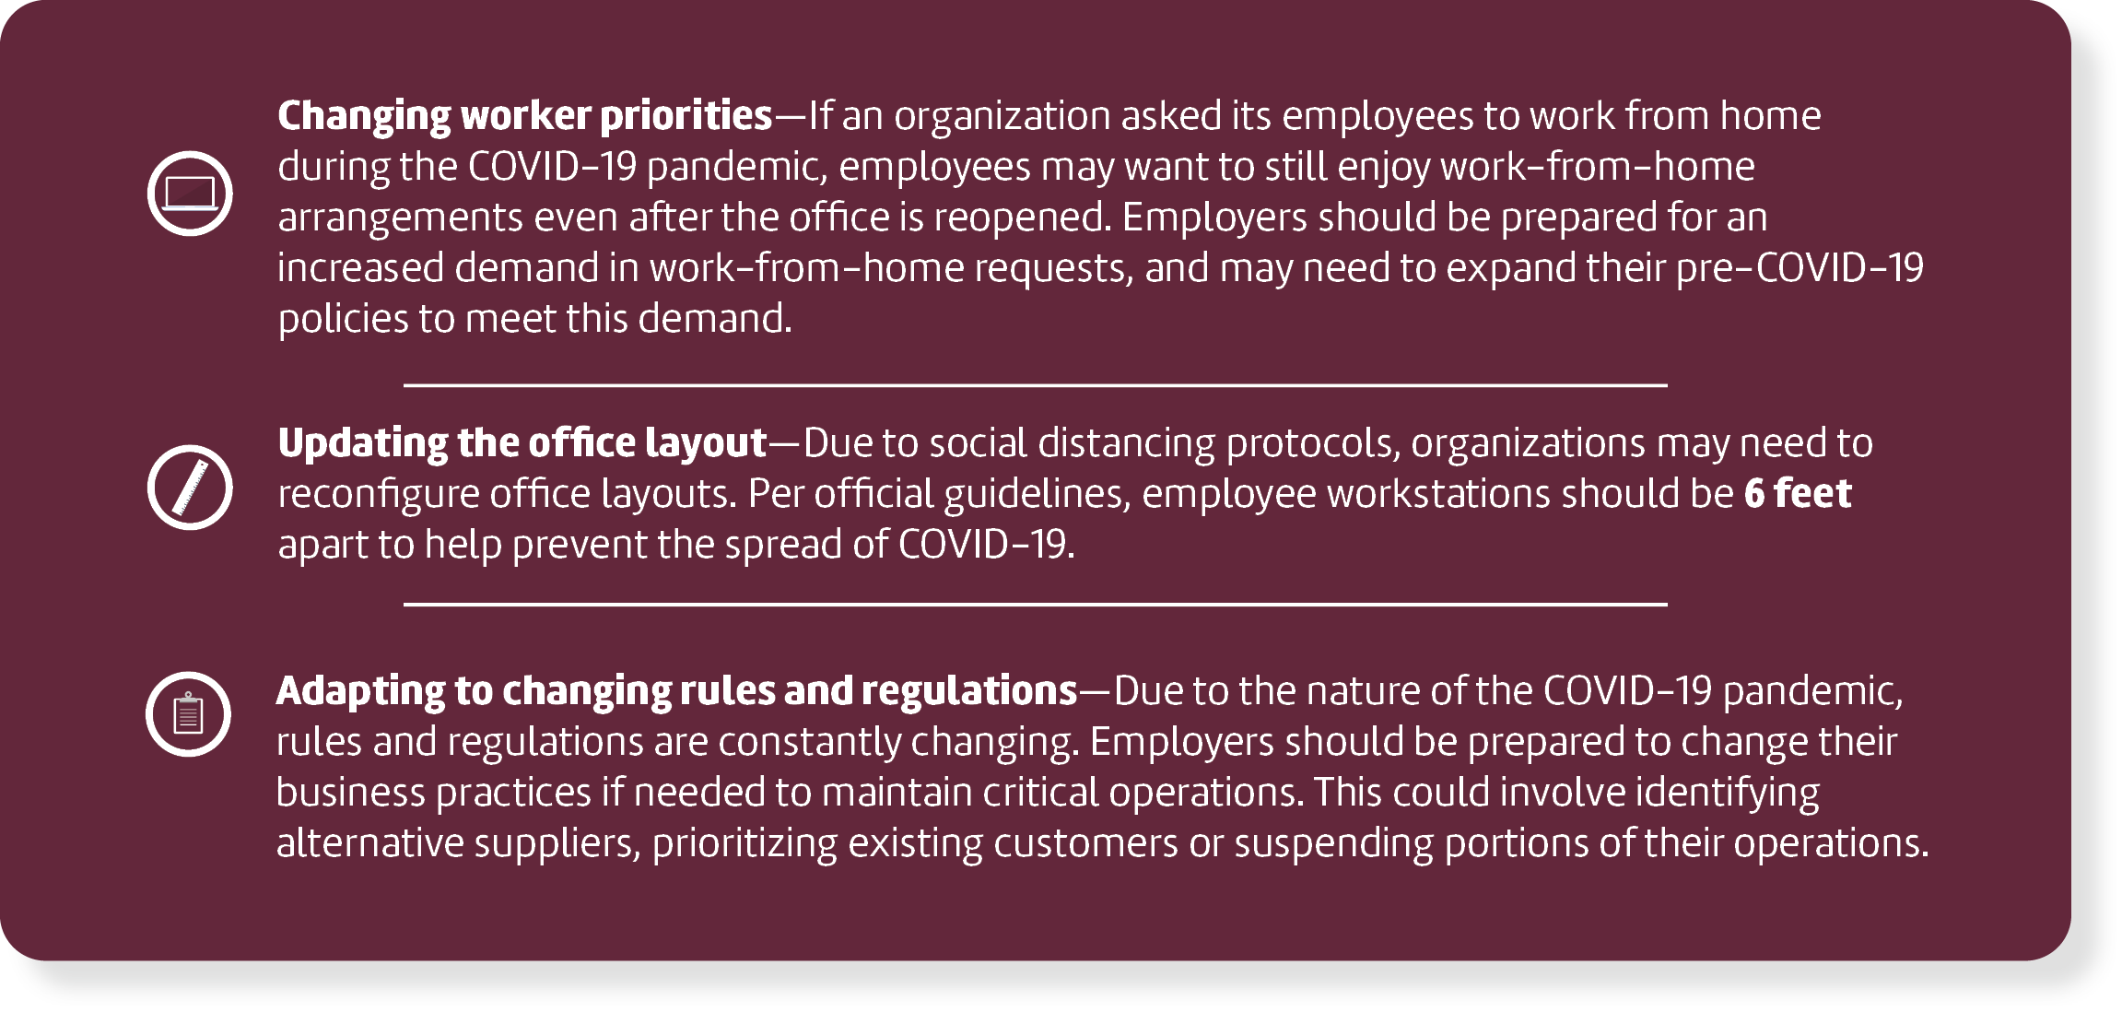

Remember, reopening a business after the COVID-19 pandemic isn’t as simple as opening the doors. Employers will need to carefully evaluate each step of the reopening and gradually ask employees to return to work.

COVID-19 Vaccine Overview
The COVID-19 pandemic has been wreaking havoc in the United States for over a year at this point. Now, vaccines are finally here. There is a lot of information on the internet regarding the vaccines, some of which is misleading. It’s important for employers to learn the facts about the COVID-19 vaccines so they can better protect their employees and customers.
This section provides an overview of the COVID-19 vaccines and answers some common questions relevant to employers. Information comes primarily from the Centers for Disease Control and Prevention (CDC).
Are There Multiple Vaccines?
There are three vaccines that have been given emergency use authorization by the Food and Drug Administration (FDA) at the time of this writing: the Pfizer-BioNTech vaccine, the Moderna vaccine and the Johnson & Johnson vaccine. The vaccines differ in some ways (namely, how they must be shipped and stored), but they are fundamentally the same.
While short of full approval, the emergency use authorization allows the COVID-19 vaccines to be distributed in the United States for individuals age 18 and older for the Moderna and Johnson & Johnson vaccines, and individuals age 16 and older for the Pfizer-BioNTech vaccine.
Are the Vaccines Worth Getting?
The vaccines have gone through rigorous vetting procedures and clinical trials, attesting to their safety and effectiveness. The vaccines not only protect the individual, but also anyone they might come into contact with. This can dramatically help curb the spread of COVID-19.
Are There Side Effects?
Like most other vaccines, these ones may come with mild side effects. These include:
- Pain, redness or swelling near where the shot was administered
- Fatigue
- Joint pain
- Chills
- Headache
- Fever
Employees experiencing these or other symptoms for more than three days should contact their primary care physician.
How Will They Be Administered?
The Pfizer-BioNTech vaccine and Moderna vaccines must be administered in two doses—one initial shot and another three to four weeks later. Getting both shots will provide the most protection, though a single dose should still offer some protective benefits, according to experts. The Johnson & Johnson vaccine only needs one shot.
Who Should Receive the Vaccines?
Individuals age 16 and up can receive a vaccine (depending on which one). However, there are some caveats to this, particularly if the individual has certain health conditions. While experts are encouraging as many people as possible to get vaccinated, anyone considering getting the vaccines should first consult their doctor.
Who Should Not Receive the Vaccines?
There has yet to be a vaccine produced for children under the age of 16, although one is expected eventually. Beyond young children, other people that should not receive the vaccines include:
- Anyone with severe allergies to any ingredients contained within the vaccines
- Anyone who experienced an allergic reaction—severe or not—after receiving their first dose of the vaccines
- Anyone with underlying medical conditions that may not respond well to the vaccines
Employees should talk to their doctors to learn whether the vaccines are safe for them to receive.
Do Employees Need the Vaccines if They Recovered From COVID-19 Already?
If someone previously contracted and recovered from COVID-19, they should still receive the vaccines if they can, according to the CDC.
When Will the Vaccines Be Available?
The vaccines are currently available only to select individuals who are at high risk of contracting COVID-19. This list includes frontline medical workers, long-term care facility staff and patients in nursing homes. Ultimately, as more doses are produced and distributed, it will be up to individual state governments to decide the order in which people can receive the vaccines.
Individuals should monitor their state’s local news to learn more about when and how the vaccines may be made available to them.
Will Employees Need to Pay for the Vaccines?
In most cases, the COVID-19 vaccines must be made available to employees without cost sharing.
Non-grandfathered group health plans, and health insurance issuers offering group or individual health insurance coverage, must cover coronavirus preventive services, including recommended COVID-19 immunizations, without cost sharing. During the COVID-19 public health emergency, covered services may be provided by in-network or out-of-network providers.
Employers interested in learning more about this rule can click here.
Can the Vaccines Be Mandatory for Employees?
In short, yes—employers may generally make receiving a vaccine a mandatory condition of employment. But that may not always be the best option for every organization. As such, employers should seek legal counsel to discuss which course of action is best for their specific circumstances.
In the meantime, the Equal Employment Opportunity Commission (EEOC) published an exhaustive list of frequently asked questions to help employers navigate this sensitive issue.
Can COVID-19 Precautions End if All Employees Are Vaccinated?
The vaccines are only one of several tools in the arsenal used to fight COVID-19. So even after receiving both doses of the vaccines, other workplace safeguards should remain in effect, including:
- Washing hands frequently
- Wearing masks
- Social distancing
- Self-quarantining if sick
There is still much unknown about the vaccines. Maintaining these precautions will help ensure a higher level of safety for employees, their families and the community at large.
Click here for more answers to COVID-19-related questions from the CDC.

COVID-19 Vaccines and the Workplace
COVID-19 vaccines have been, and will continue to be a major topic of discussion amongst employers looking to bring employees back to the office. Specifically, employers may be considering whether vaccination should be encouraged or mandated among their employees.
Employers must navigate the inherent legal risks and logistics of mandating or encouraging employees to receive the COVID-19 vaccines. To do so, employers should seek legal counsel to discuss which course of action is best for their organization. This section provides a general informational overview of considerations for employers.

Government Guidance Related to COVID-19 Vaccines and Workplaces
Government agencies, notably the Occupational Safety and Health Administration (OSHA) and the EEOC, have released guidance regarding the COVID-19 vaccines and workplace laws. Guidance from these and other authorities are likely to change as the COVID-19 pandemic evolves. Therefore, employers should continue to follow the most current information on maintaining workplace safety.
This section includes some of the most recent information available at the time of publication.

OSHA Perspective
Per OSHA, employers can require employees to receive vaccinations for influenza, providing they properly inform employees of “the benefits of vaccinations.” In addition, OSHA states that employees can refuse a vaccination due to a reasonable belief that they have an underlying medical condition that creates a real danger of serious illness or death, and that they “may be protected under Section 11(c) of the Occupational Health and Safety Act of 1970 pertaining to whistleblower rights.” Of course, employees may also refuse to receive the vaccination due to a disability or due to a sincerely held religious belief as discussed below.

EEOC Perspective
The EEOC, which enforces the ADA and Title VII of the Civil Rights Act of 1964 (Title VII), has also issued guidance regarding vaccines in the employment context. Specifically, the EEOC addressed whether employers covered by the ADA and Title VII can compel employees to receive the influenza vaccine. The commission has since made additional updates to their guidance regarding the COVID-19 vaccines, specifically.
The highlights of those updates generally clarify that:
- Employers may require employees to receive COVID-19 vaccinations;
- Employers that require vaccinations may need to provide accommodations or show that an unvaccinated employee would pose a direct threat;
- Vaccination-related questions from employers must be job-related and consistent with business necessity; and
- Any medical information obtained in the course of a vaccination program must be kept confidential.
Additionally, the EEOC explained that an employee may be entitled to an exemption from a mandatory vaccine based on a disability that prevents the employee from taking the vaccine. This would be considered a reasonable accommodation, and the employer would be required to grant the accommodation, unless it creates an undue hardship for the employer. The ADA defines an undue hardship as an action requiring significant difficulty or expense when considered in light of factors such as an employer's size, financial resources, and the nature and structure of its operation.
The EEOC also states that, under Title VII, employees with sincerely held religious beliefs may be entitled to an exemption from a mandatory vaccination, which is considered a reasonable accommodation, unless it creates an undue hardship for the employer. Note that undue hardship under Title VII is defined as a “request that results in more than a de minimis cost to the operation of the employer’s business." This is a much lower standard than under the ADA.

These and other workplace considerations are discussed in a following section.

Deciding Between a Mandatory or Voluntary Vaccination Policy
A mandatory vaccination policy (or even a voluntary policy, for that matter) may not be best for every organization. Employers will need to consider a number of factors before deciding which direction to head. This section includes considerations for employers who are weighing their policy options.

General Employer Considerations
There are a host of considerations employers need to review before coming to a decision on whether to encourage or require employees to receive a COVID-19 vaccination.
Employers should consider the following when reviewing their options:
- Evaluating undue safety burdens—Employers will face the challenge of determining whether an employee poses an undue safety burden on co-workers by choosing not to get vaccinated (if the employer is simply encouraging receiving the vaccines) or being exempt from a mandated vaccination. When evaluating this consideration, employers will need to decide whether there are other precautions that can be put into place to protect employees, which may include:

- Assessing and granting exemptions—If employers decide to require employees to get a COVID-19 vaccine, they will need to be prepared to determine whether an individual worker qualifies for a reasonable accommodation in the form of an exemption from receiving the vaccine under the ADA or Title VII. This assessment would need to be done on a case-by-case basis and could potentially leave an employer open to legal action should there be missteps at any point in the process. In addition, the employer will also have to navigate protecting the rest of the workforce should an employee be exempt from being vaccinated.
- Evaluating legal risks of requiring vaccines—Employers need to consider the possibility that they may be sued if they require employees to be vaccinated and an employee experiences an adverse reaction to the vaccines or develops subsequent health problems. There will likely be many pending cases on this subject in the future, but currently, there is no definitive answer as to how these situations will be handled in court.
- Sorting out the logistics of requiring or recommending vaccination—Regardless of whether employers require or mandate COVID-19 vaccination, there are logistical elements to consider, including:
  - Will employers hold on-site vaccination clinics?
  - What vaccine, as more than one is available on the market, will be used?
  - Who will pay for the vaccine?
  - Will the company require or cover the costs of vaccination for the employee’s family?
  - How long after the vaccine becomes available must workers receive the vaccine, if vaccination is mandated?
In addition to the considerations explained above, employers should consult legal counsel to determine whether there are unique risks to consider for their specific organization.

The Case for Mandatory Workplace Vaccination
Below are some of the arguments in favor of requiring that employees be vaccinated against COVID-19:
- Offers greater level of protection to employees, customers and all other workplace stakeholders—Vaccines are the most significant way to help prevent the spread of COVID-19 by far.
- Ensures that employees will actually be vaccinated—Instead of hoping that employees protect themselves (and the organization at large) against COVID-19, a mandatory vaccination program would force them to do so. Given the current state of affairs, there is much misinformation regarding vaccinations on the whole. A mandatory program could educate employees on its importance and increase opt-in rates.
- Saves the organization’s bottom line—Even if an employee quickly recovers from COVID-19, that won’t prevent other organizational costs, such as absenteeism, lost productivity and potentially higher health plan expenses. Moreover, experts still don’t understand the long-term effects COVID-19 can have on an individual. As such, it’s possible someone who recovered from the disease may still experience long-term health complications and, subsequently, greater medical costs.
- Keeps the organization running—Depending on the organization, a single COVID-19 infection in the workplace may be enough to cease all operations. If all workers were vaccinated, this would be much less of a concern.
- May provide some protection against civil liability. Employers are generally responsible for their employees’ well-being in the workplace. That means, if an employee contracts COVID-19 (or is exposed to it) during the course of their job duties, they may have grounds to sue their employer. Having a mandatory vaccination policy in place may help mitigate this potential.
Of course, there is still potential for legal liability down the line due to adverse vaccine reactions or, for example, missteps in the accommodation process.

The Case for Voluntary Workplace Vaccination
Below are some of the arguments in favor of a voluntary vaccination program.
- Maintains good employee relations—Employees may hold strong convictions about vaccines, preferring to quit over getting vaccinated. A voluntary vaccination policy could circumvent these negative reactions by allowing employees to act in accordance with their beliefs.
- Simplifies the policy administration—There are several workplace laws relevant to vaccination policies. In particular, the EEOC has made it clear that reasonable accommodations must be provided to employees in certain circumstances, which come with specific steps that must be taken on a case-by-case basis. This can create more administrative trouble than an employer deems worthwhile. A voluntary program would avoid these legal pitfalls.
- Provides some protection against discrimination claims—Similar to the previous point, employees may seek an accommodation from a mandatory COVID-19 vaccination policy. If they are denied, they may seek legal recourse, regardless of whether the employer is at fault. A voluntary vaccination program would not cause these concerns.
- Makes sense for some industries—Certain employers may not need all their workers vaccinated for a number of reasons. For instance, if employees can work remotely, if the staff size is small or if employees can adequately avoid close contact, it may not make sense to mandate vaccinations.

Developing a Workplace Vaccination Plan
Employers will need to carefully weigh whether a mandatory vaccine program is right for their organizations. While that decision will depend on a variety of factors, this section outlines generally how to begin that evaluation process, breaking it into six steps.

Step 1: Gauge the Situation
Employers should always consider their employees prior to making any large workplace policy decisions. In the case of a vaccine policy, employers should reach out to employees and gauge how they feel about their safety. How many feel unsafe at work? Would a mandatory vaccine policy make them feel safer than a voluntary policy? What would it take to get them to receive the vaccination? These are important questions for employers to know the answers to.
Similarly, employers should look to others in their industries to determine how vaccinations are being handled. If similar organizations aren’t adopting vaccine policies, it’s critical to understand why. While each workforce is unique, following industry trends can help employers with decision-making.
Lastly, employers must consider the potential for legal liability stemming from their decision. Both mandatory and voluntary vaccination policies come with inherent legal risks, discussed earlier. Employers are encouraged to seek legal counsel while evaluating the best course of action for their organizations.

Step 2: Make the Choice
After considering industry trends and surveying employees, employers will need to decide whether to adopt a mandatory vaccine policy, a voluntary policy or no policy at all. Each decision will come with consequences, so it’s important for employers to think carefully before this step and confer with all stakeholders, particularly legal counsel.

Step 3: Consider Incentives
Once a policy is decided upon, employers should consider ways to incentivize employees. Regardless of whether vaccination is mandatory or merely encouraged, incentives could go a long way to getting employees on board. Some organizations are using perks such as extra paid time off to increase vaccinations. That being said, employers must be cautious when choosing to offer incentives. Offering certain incentives could potentially put employers at risk of violating the ADA, which prohibits employers from “coercing” employees to participate in wellness activities.

Step 4: Ensure Resources Are in Place
Employees will undoubtedly have questions, especially if a vaccination policy is mandatory. HR should be prepared to answer these questions and provide applicable resources. Particularly, HR should know how to handle accommodation-related inquiries if employees seek exemption from the policy.

Step 5: Communicate Everything to Employees
A workplace policy of any sort can only succeed with thorough communication. Employers must make employees aware of the policy and its requirements well ahead of implementation. Employers should consider a variety of communication methods to accomplish this goal. Examples include sending mail-home flyers, posting videos on an intranet site or hosting kickoff meetings.

Step 6: Implement the Plan
Finally, employers will need to implement the plan. Details like the rollout timeline and how to handle employee accommodation requests should be decided upon prior to this step.

COVID-19 Vaccines and Workplace Laws
The availability of COVID-19 vaccinations may raise questions about the applicability of various equal employment opportunity (EEO) laws, including the ADA and the Rehabilitation Act, the Genetic Information Nondiscrimination Act (GINA) and Title VII (which includes the Pregnancy Discrimination Act). The EEO laws do not interfere with or prevent employers from following CDC or other federal, state and local public health authorities’ guidelines and suggestions.
This section provides guidance related to these key laws.

Medical Examinations and Vaccine Administration
The administration of a COVID-19 vaccine to an employee by an employer (or by a third party with whom the employer contracts to administer a vaccine) is not considered a “medical examination” for purposes of the ADA.
The vaccination itself is not a medical examination. As the EEOC explained in guidance on disability-related inquiries and medical examinations, a medical examination is “a procedure or test usually given by a health care professional or in a medical setting that seeks information about an individual’s physical or mental impairments or health.”
Examples include “vision tests; blood, urine and breath analyses; blood pressure screening and cholesterol testing; and diagnostic procedures, such as x-rays, CAT scans and MRIs.” If a vaccine is administered to an employee by an employer for protection against contracting COVID-19, the employer is not seeking information about an individual’s impairments or current health status and, therefore, it is not a medical examination.
Although the administration of a vaccination is not a medical examination, prescreening vaccination questions may implicate the ADA’s provision on disability-related inquiries, which are inquiries likely to elicit information about a disability. If the employer administers the vaccine, it must show that such prescreening questions it asks employees are “job-related and consistent with business necessity.”

Prescreening Vaccination Questions
If an employer requires an employee to receive the vaccination from the employer (or a third party) and asks screening questions (to ensure that there is no medical reason that would prevent the person from receiving the vaccination), these questions are subject to the ADA standards for disability-related inquiries.
This is because pre-vaccination medical screening questions are likely to elicit information about a disability. Therefore, such questions, if asked by the employer or a contractor on the employer’s behalf, are “disability-related” under the ADA. If the employer requires an employee to receive the vaccination, administered by the employer, the employer must show that these disability-related screening inquiries are “job-related and consistent with business necessity.” To meet this standard, an employer would need to have a reasonable belief, based on objective evidence, that an employee who does not answer the questions and, therefore, does not receive a vaccination, will pose a direct threat to the health or safety of themselves or others.
By contrast, there are two circumstances in which disability-related screening questions can be asked without needing to satisfy the “job-related and consistent with business necessity” requirement:
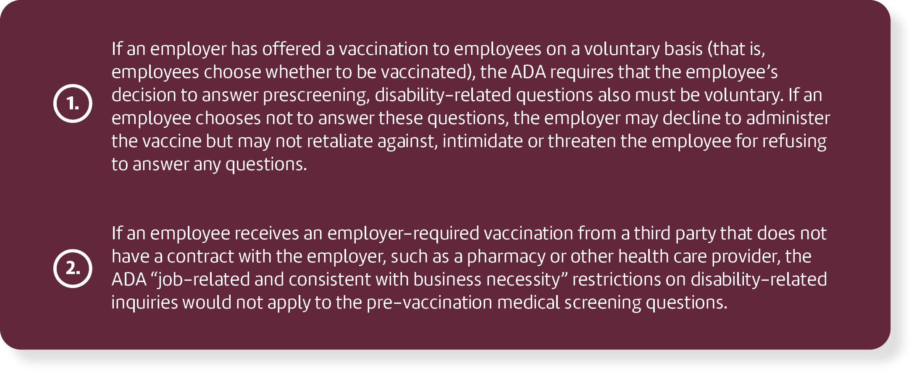

The ADA requires employers to keep any employee medical information obtained in the course of the vaccination program confidential.
Additionally, pre-vaccination medical screening questions may elicit information about genetic information, such as questions regarding the immune systems of family members. It is not yet clear what screening checklists for contraindications will be provided with COVID-19 vaccinations.
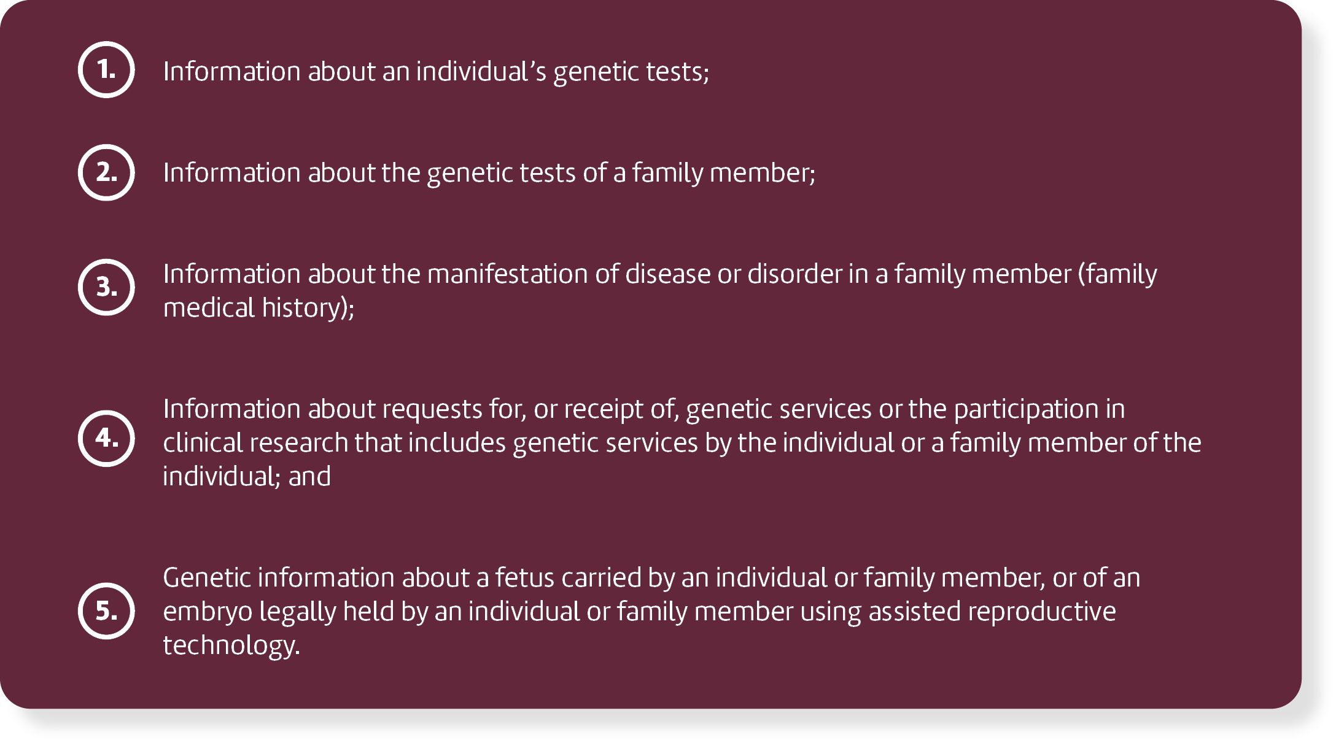
GINA defines “genetic information” to mean:

If the pre-vaccination questions do not include any questions about genetic information (including family medical history), then asking them does not implicate GINA. However, if the pre-vaccination questions do include questions about genetic information, then employers that want to ensure that employees have been vaccinated may want to request proof of vaccination instead of administering the vaccine themselves.
GINA does not prohibit an individual employee’s own health care provider from asking questions about genetic information, but it does prohibit an employer or a doctor working for the employer from asking questions about genetic information. If an employer requires an employee to provide proof that they have received a COVID-19 vaccination from their own health care provider, the employer may want to warn the employee not to provide genetic information as part of the proof. As long as this warning is provided, any genetic information the employer receives in response to its request for proof of vaccination will be considered inadvertent and therefore not unlawful under GINA.

COVID-19 Vaccination Verification and Disability-related Inquiries
Asking or requiring an employee to show proof of receipt of a COVID-19 vaccination is not a disability-related inquiry.
There are many reasons that may explain why an employee has not been vaccinated, which may or may not be disability-related. Simply requesting proof of receipt of a COVID-19 vaccination is not likely to elicit information about a disability and, therefore, is not a disability-related inquiry. However, subsequent employer questions, such as asking why an individual did not receive a vaccination, may elicit information about a disability and would be subject to the pertinent ADA standard that they be “job-related and consistent with business necessity.” If an employer requires employees to provide proof that they have received a COVID-19 vaccination from a pharmacy or their own health care provider, the employer may want to warn the employees not to provide any medical information as part of the proof in order to avoid implicating the ADA.

Emergency Use Authorization (EUA) and the COVID-19 Vaccine
Some COVID-19 vaccines may only be available to the public for the foreseeable future under EUA granted by the FDA, which is different than approval under FDA vaccine licensure. The FDA has an obligation to ensure that recipients of the vaccines under an EUA are informed, to the extent practicable under the applicable circumstances, that FDA has authorized the emergency use of the vaccines, of the known and potential benefits and risks, the extent to which such benefits and risks are unknown, that they have the option to accept or refuse the vaccines, and of any available alternatives to the product.
The FDA says that this information is typically conveyed in a patient fact sheet that is provided at the time of the vaccine administration and that it posts the fact sheets on its website. More information about EUA vaccines is available on the FDA’s EUA page.

Employees with Disabilities Preventing Vaccination
If an employer requires vaccinations (when they are available), they must respond carefully to an employee who indicates that they are unable to receive a COVID-19 vaccination because of a disability.
The ADA allows an employer to have a qualification standard that includes “a requirement that an individual shall not pose a direct threat to the health or safety of individuals in the workplace.” However, if a safety-based qualification standard, such as a vaccination requirement, screens out or tends to screen out an individual with a disability, the employer must show that an unvaccinated employee would pose a direct threat due to a “significant risk of substantial harm to the health or safety of the individual or others that cannot be eliminated or reduced by reasonable accommodation.”
Employers should conduct an individualized assessment of the following four factors in determining whether a direct threat exists:

A conclusion that there is a direct threat would include a determination that an unvaccinated individual will expose others to the virus that causes COVID-19 at the worksite. If an employer determines that an individual who cannot be vaccinated due to disability poses a direct threat at the worksite, the employer cannot exclude the employee from the workplace—or take any other action—unless there is no way to provide a reasonable accommodation (absent undue hardship) that would eliminate or reduce this risk so the unvaccinated employee does not pose a direct threat.
If there is a direct threat that cannot be reduced to an acceptable level, the employer can exclude the employee from physically entering the workplace, but this does not mean the employer may automatically terminate the worker. Employers will need to determine whether any other rights apply under the EEO laws or other federal, state and local authorities.
For example, if an employer excludes an employee based on an inability to accommodate a request to be exempt from a vaccination requirement, the employee may be entitled to accommodations such as performing the current position remotely. This is the same step that employers take when physically excluding employees from a worksite due to a current COVID-19 diagnosis or symptoms.
Managers and supervisors responsible for communicating with employees about compliance with the employer’s vaccination requirement should know how to recognize an accommodation request from an employee with a disability and know to whom the request should be referred for consideration. Employers and employees should engage in a flexible, interactive process to identify workplace accommodation options that do not constitute an undue hardship (significant difficulty or expense).
This process should include determining whether it is necessary to obtain supporting documentation about the employee’s disability and considering the possible options for accommodation given the nature of the workforce and the employee’s position. The prevalence in the workplace of employees who already have received a COVID-19 vaccination and the amount of contact with others, whose vaccination status could be unknown, may impact the undue hardship consideration.
In discussing accommodation requests, employers and employees also may find it helpful to consult the Job Accommodation Network (JAN) website as a resource for different types of accommodations. JAN’s materials specific to COVID-19 are available here.
Employers may rely on CDC recommendations when deciding whether an effective accommodation that would not pose an undue hardship is available, but as explained further in Question K.7, there may be situations where an accommodation is not possible. When an employer makes this decision, the facts about particular job duties and workplaces may be relevant. Employers also should consult applicable OSHa standards and guidance. Employers can find OSHA COVID-specific resources here.
Managers and supervisors are reminded that it is unlawful to disclose that an employee is receiving a reasonable accommodation or retaliate against an employee for requesting an accommodation.

Sincere Religious Beliefs Preventing Vaccination
If an employer requires vaccinations (when they are available), they must respond carefully to an employee who indicates that they are unable to receive a COVID-19 vaccination because of a sincerely held religious practice or belief.
Once an employer is on notice that an employee’s sincerely held religious belief, practice or observance prevents the employee from receiving the vaccination, the employer must provide a reasonable accommodation for the religious belief, practice or observance unless it would pose an undue hardship under Title VII of the Civil Rights Act.
Courts have defined “undue hardship” under Title VII as having more than a de minimis cost or burden on the employer. EEOC guidance explains that because the definition of religion is broad and protects beliefs, practices and observances with which the employer may be unfamiliar, the employer should ordinarily assume that an employee’s request for religious accommodation is based on a sincerely held religious belief. If, however, an employee requests a religious accommodation, and an employer has an objective basis for questioning either the religious nature or the sincerity of a particular belief, practice or observance, the employer would be justified in requesting additional supporting information.

No Reasonable Accommodation Available
If an employee cannot get vaccinated for COVID-19 because of a disability or sincerely held religious belief, practice or observance, and there is no reasonable accommodation possible, then it would be lawful for the employer to exclude the employee from the workplace. This does not mean the employer may automatically terminate the worker. Employers will need to determine whether any other rights apply under the EEO laws or other federal, state and local authorities.

Genetic Information, Employment Decision-making and Vaccinations
Title II of GINA is not implicated when an employer administers a COVID-19 vaccine to employees or requires employees to provide proof that they have received a COVID-19 vaccination.
Administering a COVID-19 vaccination to employees or requiring employees to provide proof that they have received a COVID-19 vaccination does not implicate Title II of GINA because it does not involve the use of genetic information to make employment decisions, or the acquisition or disclosure of “genetic information” as defined by the statute. This includes vaccinations that use messenger RNA (mRNA) technology. However, if administration of the vaccine requires prescreening questions that ask about genetic information, the inquiries seeking genetic information, such as family members’ medical histories, may violate GINA.

Under Title II of GINA, employers may not:
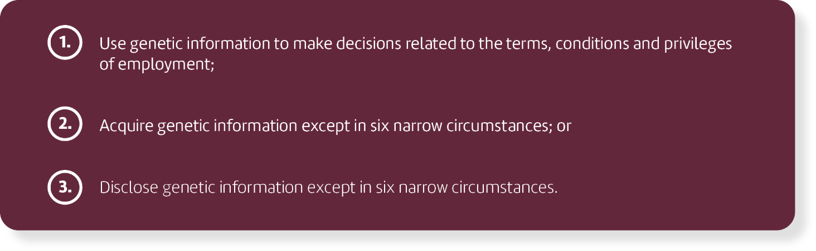

Certain COVID-19 vaccines use mRNA technology. This raises questions about genetics and, specifically, about whether such vaccines modify a recipient’s genetic makeup and, therefore, whether requiring an employee to get the vaccine as a condition of employment is an unlawful use of genetic information. The

CDC has explained that the mRNA COVID-19 vaccines “do not interact with our DNA in any way” and “mRNA never enters the nucleus of the cell, which is where our DNA (genetic material) is kept.” (See this link for a detailed discussion about how mRNA vaccines work). Thus, requiring employees to get the vaccine, whether it uses mRNA technology or not, does not violate GINA’s prohibitions on using, acquiring or disclosing genetic information.

Appendix
Explore this fully printable appendix for deliverables that can be used right now. It includes policies, employee communications and more.

Printing Help
There are many printable resources in this appendix. Please follow the instructions below if you need help printing individual pages.
- Choose the “Print” option from the “File” menu.
- Under the “Settings” option, click on the arrow next to “Print All Pages” to access the drop-down menu. Select “Custom Print” and enter the page number range you would like to print, or enter the page number range you would like to print in the “Pages” box.
- Click “Print.” For more information, please visit the Microsoft Word printing support page.

Mandatory COVID-19 Vaccination Policy
Purpose
has adopted the following mandatory vaccination policy in keeping with our commitment to provide a safe and hazard-free work environment for our employees, their families, visitors and local community. drafted this policy in compliance with all applicable federal and state laws, including guidance from the Centers for Disease Control and Prevention (CDC) and local health authorities.
Procedures
is requiring that all employees receive and provide proof of a COVID-19 vaccination by [insert deadline]. Any individual seeking an exemption from this policy should speak with the human resources department as soon as possible.

The [human resources department] will notify employees as to which vaccinations will be required under this policy, and the deadline for compliance. [will provide a list of local facilities offering the vaccination] [will provide access to the vaccine on company premises]. Employees are expected to consult with their respective managers regarding the best time to be excused to receive the vaccine.

Employees must certify prior to the deadline that they either received the vaccine or obtained an approved exemption from as detailed below. Employees may certify that they received a vaccination by presenting [insert desired form of proof]. Employees who fail to meet one of the aforementioned criteria by the designated deadline will be [insert discipline].

Reasonable Accommodations

Employees who request an exemption from this policy for medical, religious or any other reason must submit a [request for accommodation form] to [human resources department] as soon as possible. Once the company has been made aware of the need for an accommodation, the request will be evaluated in a manner consistent with all applicable laws.

For additional information, please contact [insert contact name].

Voluntary COVID-19 Vaccination Policy
Purpose
has adopted the following voluntary vaccination policy in keeping with our commitment to provide a safe and hazard-free work environment for our employees, their families, visitors and local community. drafted this policy in compliance with all applicable federal and state laws, including guidance from the Centers for Disease Control and Prevention (CDC) and local health authorities.
Procedures
is encouraging all employees to receive a COVID-19 vaccination within [insert designated time frame]. The [human resources department] will notify employees as to which vaccinations will be covered by this policy [and the time frame by which employees are encouraged to abide]. [will provide a list of local facilities offering the vaccination] [will provide access to the vaccine on company premises]. Employees are expected to consult with their respective managers regarding the best time to be excused to receive the vaccine.

Employees who receive the vaccine will need to certify that fact within the designated time frame. Employees may certify that they received a vaccination by presenting [insert desired form of proof]. Employees who fail to become vaccinated within the designated time frame will be required to wear a face covering all at times while on premises unless they have obtained an approved exemption.

Reasonable Accommodations

Employees who request an exemption from the requirement to wear a face covering for medical, religious or any other reason must submit a [request for accommodation form] to [human resources department] as soon as possible. Once has been made aware of the need for an accommodation, the request will be evaluated in a manner consistent with all applicable laws.

For additional information, please contact [insert contact name].

Mandatory COVID-19 Vaccination Letter to Employees

3/11/2021

Dear Employee,

is requiring that all employees receive the COVID-19 vaccine, effective [insert date] [, in accordance with our mandatory vaccination policy]. This is in keeping with our commitment to providing a safe and hazard-free work environment for our visitors, employees and their families.
All employees must receive their COVID-19 vaccine by [insert date]. Any individual seeking a delay or exemption—for medical, religious or any other reason—should speak with human resources as soon as possible.
will cover all expenses related to receiving the vaccine.
[Optional: Insert details about where employees can get the vaccine, including location, time and provider.]
For additional information, please contact [insert contact name].

Regards,

Voluntary COVID-19 Vaccination Letter to Employees

3/11/2021

Dear Employee,

is encouraging all employees to receive the COVID-19 vaccine [, as part of our voluntary vaccination policy]. This is in keeping with our commitment to providing a safe and hazard-free work environment for our visitors, employees and their families.
Employees may choose where they like to receive the vaccination, though will provide vaccinations on-site through [insert vaccine provider]. Expect more details to follow.
[Optional: Delete the previous sentence and include details here, including the vaccine provider, when they will be on-site and other necessary information.]
Should you choose to receive the vaccine, will cover all related expenses.
For additional information, please contact [insert contact name].

Regards,

COVID-19 Vaccination Employee Letter for Essential Workers

Dear Employee,

Across the country, the COVID-19 pandemic is having devastating effects. We appreciate how much you have already done to adapt during this challenging time. As you know, we have been taking preventive measures at against COVID-19 for the past several months to help keep you, our entire staff, your families and our customers safe. We have worked under some uncertain and often stressful conditions, and you have helped make it possible for us to continue our essential operations.
It’s important that essential workers like you are vaccinated because of your role in maintaining critical infrastructure operations. Essential workers are at increased risk of getting COVID-19 and spreading it to others because work-related duties must be performed on-site and involve being in close contact (within 6 feet for a cumulative total of 15 minutes in a 24-hour period) with the public or co-workers.
Getting the COVID-19 vaccine gives you an added layer of protection against COVID-19 and could also protect your co-workers and your family. Here are some key points about COVID-19 vaccination:
- All COVID-19 vaccines available in the United States are very effective at preventing the disease.
- The most common side effects are pain in the arm where you got the shot, feeling tired, headache, body aches, chills and fever.
- Stopping a pandemic requires using all the tools we have available—wearing masks, staying at least 6 feet from people who don’t live with you, avoiding crowds and poorly ventilated spaces, washing your hands frequently and getting vaccinated.
[Optional, if you have scheduled vaccination clinics] Your health and safety continue to be our priority and, to ensure convenient access to vaccination, we will have vaccines available to our staff at [insert information about where to get vaccinated].
If you have questions about our vaccination clinics, please contact [insert name and contact information for your company’s point of contact].
If you want to know more about COVID-19 vaccines, visit www.cdc.gov/coronavirus/2019-ncov/vaccines.

Sincerely,

Employer Will Cover the Cost of COVID-19 Testing Letter

3/11/2021

Dear Employee,

is committed to protecting the health of our employees. As such, we will be fully covering the cost of COVID-19 testing procedures.
To learn more about this policy, please contact human resources at [insert contact information].

Kind regards,

Welcome Back to Work - Employee Communications Letter

Dear Employee,
Welcome back to work! We’ve been looking forward to the day we’d be able to reopen our doors to our employees. [Sample text regarding the decision to reopen: The decision to reopen our business was not taken lightly—we carefully reviewed federal, state and local reopening guidelines and considerations. After much discussion, we decided that we could reopen our doors and created a plan that will help us do so while preserving your health and safety.]
At , it is our priority to keep our employees and their families healthy, especially in the midst of the COVID-19 pandemic. As such, we will abide by governmental guidelines when possible as we strive to balance public health concerns with the needs of our business. Some notable workplace changes include the following:
[This list below features sample text regarding workplace updates and needs to be updated before distributing to employees.]
- Modified office layout—We’ve updated workstations to ensure that they’re suitable for social distancing protocols, closed our communal spaces and set up no-touch doors.
- Increased office cleaning—Cleaning crews will clean the office twice daily, focusing on sanitizing and disinfecting high-touch surfaces.
- Updated employee protocols—We’ve implemented various employee health and safety protocols that focus on social distancing, health screening and general hygiene reminders to keep our employees safe and healthy while returning to work.

While we will implement various protocols to ensure your safety, it’s up to you and your co-workers to execute on these protocols daily. hopes to clearly communicate our plans moving forward, highlight workplace protocols in place to protect your safety and establish a level of comfort for all of our employees as we ask you to return to the office.
With that being said, we want you to feel as comfortable as possible in your return to work. Please let your manager or HR know if you feel there is another process or procedure we can implement to further protect the health and safety of all employees. In addition, we understand that every employee’s situation is different and encourage those with specific risks or concerns to reach out to their manager or HR to discuss alternate arrangements, should they be necessary.
is excited to welcome you back to work, and we’re confident that, by working together, we can establish a safe, new normal that works for our business and employees. We feel that the plans and procedures put in place will help make your transition back to the office a success, but we want to know how our plans can be improved. Please reach out to your manager or HR with your suggestions. We’d love to hear them!
Sincerely,

COVID-19 Symptom Screening Checklist
This checklist follows guidance from the Centers for Disease Control and Prevention (CDC) for monitoring symptoms consistent with COVID-19, and exposures to the virus that causes it.
Please fill out and return this checklist.
Printed name:_________________________________________
Signature:____________________________________________ Date:___________________________
Do you have any of the following symptoms that are not caused by another condition? | Yes | No
Fever or chills | ☐ | ☐
Cough | ☐ | ☐
Shortness of breath or difficulty breathing | ☐ | ☐
Fatigue | ☐ | ☐
Muscle or body aches | ☐ | ☐
Headache | ☐ | ☐
New loss of taste or smell | ☐ | ☐
Sore throat | ☐ | ☐
Congestion or runny nose | ☐ | ☐
Nausea or vomiting | ☐ | ☐
Diarrhea | ☐ | ☐

Have you recently experienced any of the following COVID-19 emergency warning signs? | Yes | No
Trouble breathing | ☐ | ☐
Persistent pain or pressure in the chest | ☐ | ☐
New confusion | ☐ | ☐
Inability to wake or stay awake | ☐ | ☐
Bluish lips or face | ☐ | ☐

COVID-19 Screening Questions | Yes | No
Within the past 14 days, have you been in close physical contact (6 feet or closer for at least 15 minutes) with a person known to have laboratory-confirmed COVID-19 or with anyone who has any symptoms consistent with COVID-19? | ☐ | ☐
Within the past 14 days, has a public health or health care professional advised you to self-monitor, isolate or quarantine because of concerns about COVID-19 infection? | ☐ | ☐
Have you had a positive COVID-19 test in the past 10 days? | ☐ | ☐

COVID-19 Vaccine Workplace Planning Checklist
Employers can play a key role in COVID-19 vaccine distribution and should prepare for when vaccine access reaches the general public. This document compiles guidance from the Centers for Disease Control and Prevention (CDC) and offers considerations for employers when conducting COVID-19 vaccine workplace planning. To get started, employers can review topics on this checklist.

Initial COVID-19 Vaccine Planning | YES | NO | N/A
Is your organization monitoring vaccine availability from the CDC and local health officials? | ☐ | ☐ | ☐
Has your organization determined whether your workplace will have a mandatory or voluntary vaccination policy? | ☐ | ☐ | ☐
Has your organization determined your workplace’s eligibility to offer on-site vaccinations? | ☐ | ☐ | ☐

COVID-19 Vaccine Policy Development | YES | NO | N/A
Has your organization created a voluntary or mandatory COVID-19 workplace vaccine policy? | ☐ | ☐ | ☐
If applicable, does your vaccination policy specify a date by which a vaccination will be required? | ☐ | ☐ | ☐
If applicable, does your vaccination policy specify how employees can certify they have received a vaccination? | ☐ | ☐ | ☐
If applicable, does your vaccination policy specify disciplinary actions for not complying by the designated deadline? | ☐ | ☐ | ☐
If applicable, has your workplace developed a policy for employees who have a medical, religious or other exemption from receiving the vaccine? | ☐ | ☐ | ☐
Has your workplace developed a policy for employees to take time off to receive the vaccine, and if necessary, take time off work due to potential side effects? | ☐ | ☐ | ☐

COVID-19 Vaccine Distribution Planning | YES | NO | N/A
Has your organization determined whether your workplace will offer on-site vaccinations? | ☐ | ☐ | ☐

If offering vaccinations on-site, has your organization planned for the logistics of vaccine distribution? | ☐ | ☐ | ☐
If not offering vaccinations on-site, has your organization determined alternative sites where employees can receive vaccines? | ☐ | ☐ | ☐
Has your organization created a schedule for employees to get vaccinated (factoring potential worker shortages due to the time required to get the vaccine, and if necessary, recover from potential side effects)? | ☐ | ☐ | ☐
Has your organization established how employees should determine when to get vaccinated (e.g., consult with manager, follow a staggered schedule or other practice)? | ☐ | ☐ | ☐

Employee Communications Planning | YES | NO | N/A
Is your organization sharing any updates with employees on an ongoing basis? | ☐ | ☐ | ☐
Is your organization using multiple channels that effectively reach all employees? | ☐ | ☐ | ☐
Has your organization established two-way communications with employees and specified a point of contact for employees who have questions, comments or concerns? | ☐ | ☐ | ☐
COVID-19 Vaccine Communication Topics | YES | NO | N/A
Has your organization shared general information about the COVID-19 vaccines with employees?  - Overview of available vaccines and their differences  - Number of doses required for vaccination  - Facts and myths about the vaccine  - How vaccines work  - Benefits  - Efficacy and safety  - Possible side effects | ☐ | ☐ | ☐
Is your organization keeping employees up to date on expected vaccination timelines for your workplace? | ☐ | ☐ | ☐
Has your organization’s voluntary or mandatory vaccination policy been shared with employees? | ☐ | ☐ | ☐
Has your organization shared details with employees for how to request a medical, religious or other vaccination exemption? | ☐ | ☐ | ☐
Has your organization shared expectations for vaccination scheduling (e.g., requiring employees to consult with a manager, follow a staggered schedule or other practice)? | ☐ | ☐ | ☐
Has your organization provided employees with vaccination site details (whether employees will receive a vaccine on-site, or at an alternative site)? | ☐ | ☐ | ☐
Has your organization provided employees with details for vaccination costs (including potential paid time off for getting vaccinated or recovering from any side effects)? | ☐ | ☐ | ☐
Has your organization clarified expectations of employees for continued COVID-19 safety precautions or protocols, such as hand-washing, mask-wearing and avoiding close contact in the workplace? | ☐ | ☐ | ☐

Workplace Reopening | YES | NO | N/A
Has your organization planned for how vaccinations will impact efforts to reopen the workplace? | ☐ | ☐ | ☐
Has your organization established post-vaccination safety precautions or protocols, including social distancing, hand-washing and mask requirements? | ☐ | ☐ | ☐

Responding to a Positive COVID-19 Test Checklist
The COVID-19 pandemic has challenged employers to plan for how they would respond to a positive test in their workplace. Employers are responsible for handling the situation swiftly to protect the health of other employees while preserving the affected employee’s confidentiality. In addition to notifying the company and its customers, employers must also disinfect the office and evaluate next steps. If you’re in this situation, you may be wondering what you need to do. The Centers for Disease Control and Prevention (CDC) provides guidelines for how employers can respond, and this checklist provides an outline of steps for employers to consider.

Employer Preparedness Plans | YES | NO | N/A
Does your organization have COVID-19 testing practices in place that comply with all applicable federal and local guidance? | ☐ | ☐ | ☐
Does your organization have a planned response in place in the event of an employee testing positive for COVID-19? | ☐ | ☐ | ☐
If yes, has a planned response been communicated to employees? | ☐ | ☐ | ☐

Addressing Employee Who Tested Positive
Calmly and empathetically address the employee to discuss next steps and assistance. | ☐
Ensure the employee that their identity will remain confidential. | ☐
Question the employee about with whom they have been in contact within the last 14 days. | ☐
Determine if the employee has been in the workplace within the last seven days. | ☐
Ensure the employee goes into isolation, and help them coordinate taking leave or paid time off until they’ve recovered. | ☐
Refer the employee to local health resources. | ☐

Communications
Notify any co-workers or customers with whom the ill employee had been in contact. | ☐
Make determinations on any employees who should begin self-isolation for 14 days. Communicate steps for self-isolation, including taking leave, paid time off or remote work arrangements. | ☐
Notify the rest of the company by email or letter that an employee has tested positive for COVID-19. Keep the employee’s identity confidential. | ☐
Notify employees on next steps, including details for a partial or full closing of the workplace for disinfecting. | ☐
If planning on having any or all employees work from home or closing the office, disclose this information in the communication. | ☐

Close Down the Workplace
Determine whether the workplace will be partially or fully closing for disinfecting. | ☐
If feasible, allow eligible employees to work from home during this time. | ☐
Ensure all temporary closing information is communicated to employees, including whom this affects, remote work expectations, paid time off, leave and expected timelines for reopening the workplace. | ☐
Review provisions included in the newly instituted federal leave act, the Families First Coronavirus Response Act (FFCRA), should you need to close the office or if employees opt to take leave due to COVID-19. Certain employers are required to provide employees with expanded family and medical leave for specified reasons related to COVID-19 through Dec. 31, 2020. | ☐
Create plans for only cleaning staff to be in infected areas for 72 hours during the disinfecting period. | ☐

Preparing for Disinfecting
If the employee has been in the workplace within the last seven days, begin preparations for disinfecting the workplace. | ☐
Ensure necessary cleaning supplies are stocked, including soap and disinfectants listed by the Environmental Protection Agency (EPA) to use against SARS-CoV-2, the virus that causes COVID-19. | ☐
Ensure personal protective equipment is stocked for cleaning teams, including gloves, gowns and face coverings. | ☐
Evacuate planned areas for disinfecting for at least 72 hours. | ☐

Disinfecting the Workplace
Close off all areas visited by the person, open windows and use ventilating fans with airflow. After opening up the airflow, wait 24 hours before beginning cleaning. | ☐
After 24 hours, cleaning staff should begin disinfecting all areas and equipment used by the person. | ☐
Ensure cleaning staff is using personal protective equipment, including gloves, gowns and face coverings. | ☐
Begin by cleaning all hard surfaces with soap and water. | ☐
Apply a disinfectant to all surfaces. The EPA lists appropriate disinfectants for use against SARS-CoV-2, the virus that causes COVID-19. | ☐
Clean soft surfaces such as carpeted floor, rugs and drapes. For soft surfaces, best cleaning practices are similar to those of hard surfaces. However, you can clean by laundering if possible. If not an option, continue to clean with a disinfectant. | ☐
Clean electronic devices, according to manufacturers’ instructions, or with alcohol-based cleaning solutions with at least 70% alcohol. | ☐
Clean soft laundry items, such as towels, linens and work-related clothing using manufacturers’ instructions, using the warmest possible water setting. | ☐
When employees return after 72 hours, resume routine cleaning routines. | ☐

Use this checklist as a guide when planning how to respond to an employee testing positive for COVID-19. For any items you are unable to check, consider whether any updates to your organization’s response could help protect the health and safety of employees and guests. By preparing in advance, employers can swiftly respond to the employee, effectively notify the rest of their organization and make plans for moving forward. AdvanStaff HR is here to help during these uncertain times. Contact us today for additional COVID-19 resources and guidance for how your company can respond to it.

Return-to-Work Communications Planning Checklist
The COVID-19 pandemic has challenged existing practices in the workplace, and many employers are implementing return-to-work plans—which often include updating expectations for employees and partners. When utilizing effective communications, organizations can equip employees to contribute to post-coronavirus efforts. By being proactive and establishing effective communication plans, employers can not only help prevent the spread of COVID-19 but put employees at ease, knowing that necessary steps are being taken to best ensure their health and safety. As return-to-work updates often influence various workplace changes, organizations may also want to consider how to effectively communicate with customers, vendors, guests and local officials. To get started, employers can review how topics on this checklist fit into their communications strategy.

Employee Relations | YES | NO | N/A
Are employees being referred to a primary channel of communications for COVID-19-related updates? | ☐ | ☐ | ☐
Have employees received communications regarding expectations for hand-washing? | ☐ | ☐ | ☐
Have employees received communications regarding expectations for proper social distancing? | ☐ | ☐ | ☐
If employees are expected to wear face coverings or masks in the workplace, have expectations been communicated? | ☐ | ☐ | ☐
If face coverings or masks are not provided to employees, have details been communicated for any face covering or mask cost reimbursement programs? | ☐ | ☐ | ☐
Have employees received communications regarding policies in place to protect employees in COVID-19 high-risk categories? | ☐ | ☐ | ☐
Have employees received communications regarding any updates to remote work policies? | ☐ | ☐ | ☐
Have employees received communications regarding any updates to business travel policies? | ☐ | ☐ | ☐
Have updated expectations for meetings been communicated to employees? | ☐ | ☐ | ☐
Have employees received information on existing or new leave policies? | ☐ | ☐ | ☐
Has your organization provided communications on updated virus-resistant cleaning procedures, including any expectations of employees? | ☐ | ☐ | ☐
Has your organization provided employees with health and wellness resources? | ☐ | ☐ | ☐

Training Employees | YES | NO | N/A
Are employees trained on what COVID-19-related symptoms to look for? | ☐ | ☐ | ☐
Are employees trained on proper hand-washing, including how and when to wash their hands? | ☐ | ☐ | ☐
If using face coverings or masks, have employees been trained on proper procedures? | ☐ | ☐ | ☐
Are employees trained on cleaning and disposing of personal protective equipment, including face coverings, masks and gloves? | ☐ | ☐ | ☐
Have cleaning teams been trained on coronavirus-resistant best practices, including cleaning surfaces with use of disinfectants that are listed by the Environmental Protection Agency (EPA) to use against SARS-CoV-2, the virus that causes COVID-19? | ☐ | ☐ | ☐
Are employees aware that thorough cleaning procedures do not replace best practices, such as social distancing? | ☐ | ☐ | ☐

Monitoring COVID-19 Symptoms | YES | NO | N/A
If conducting COVID-19 screenings on-site, have employees received communications clarifying the process of screenings? | ☐ | ☐ | ☐
If conducting COVID-19 screenings on-site, have employees been assured that all screenings will be conducted using safe practices and in full compliance with all federal and local laws? | ☐ | ☐ | ☐
Are employees aware of follow-up steps should they display COVID-19-related symptoms? | ☐ | ☐ | ☐

Customers, Vendors and Guests | YES | NO | N/A
Are ongoing business updates communicated to customers? | ☐ | ☐ | ☐
Has ongoing dialogue been established with vendors? | ☐ | ☐ | ☐
Have any updates to visitation or guest policies been shared both internally and externally? | ☐ | ☐ | ☐

Local Health Officials | YES | NO | N/A
Is your organization following guidance from local health officials and establishing ongoing dialogue as necessary? | ☐ | ☐ | ☐
Is your organization prepared to utilize local health resources in the event of a positive COVID-19 test and recommend health resources to affected employees? | ☐ | ☐ | ☐

Future Preparedness | YES | NO | N/A
Does your organization have a planned response in place in the event of an employee testing positive for COVID-19? | ☐ | ☐ | ☐
Have disinfecting and cleaning plans been communicated to employees in the event of an employee testing positive for COVID-19? | ☐ | ☐ | ☐
Does your planned response include notifying employees and guests of a positive COVID-19 test? | ☐ | ☐ | ☐
Does your organization have a preparedness plan for communicating updates for any future partial or full closings of the workplace? | ☐ | ☐ | ☐

Use this checklist as a guide when planning your organization’s post-coronavirus communications plans. For any checklist items you select “NO,” consider whether any changes could help ensure return-to-work plans are communicated effectively. For assistance with COVID-19-related topics, contact AdvanStaff HR.

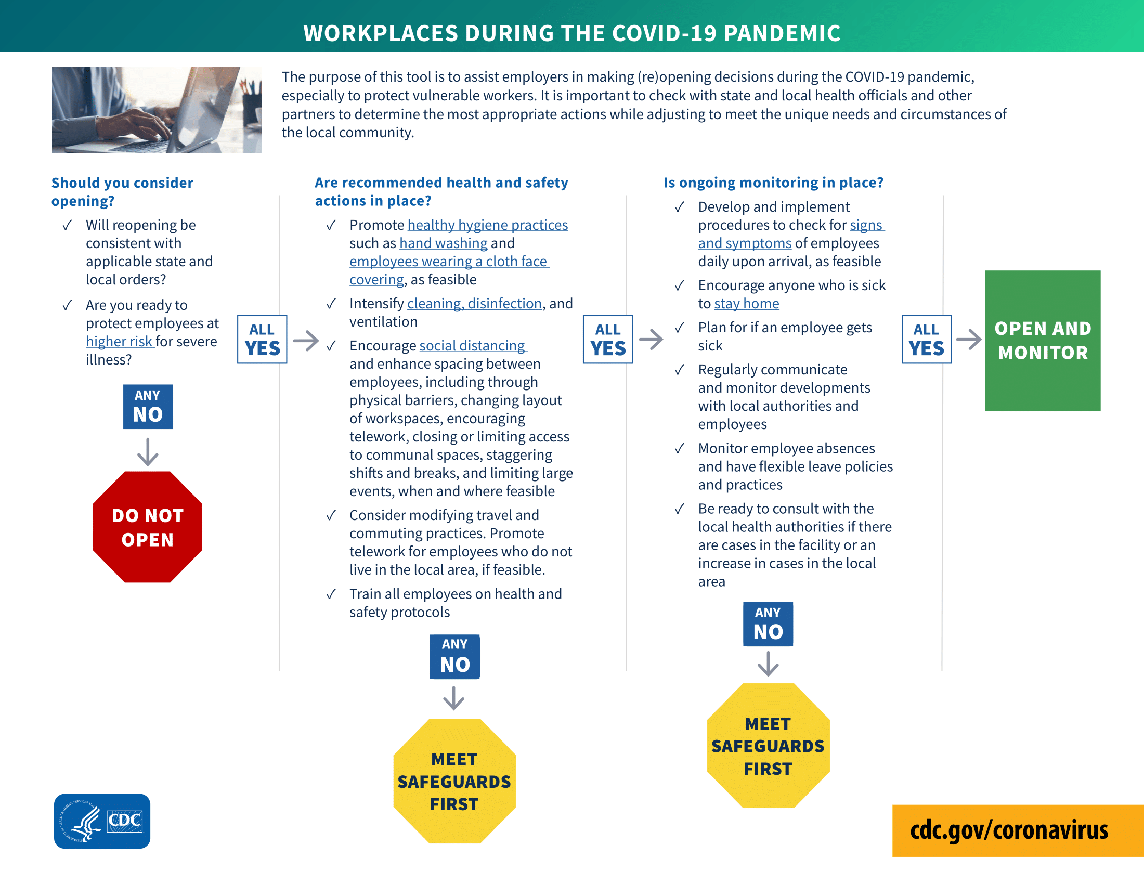

Workplace Reopening Decision Infographic

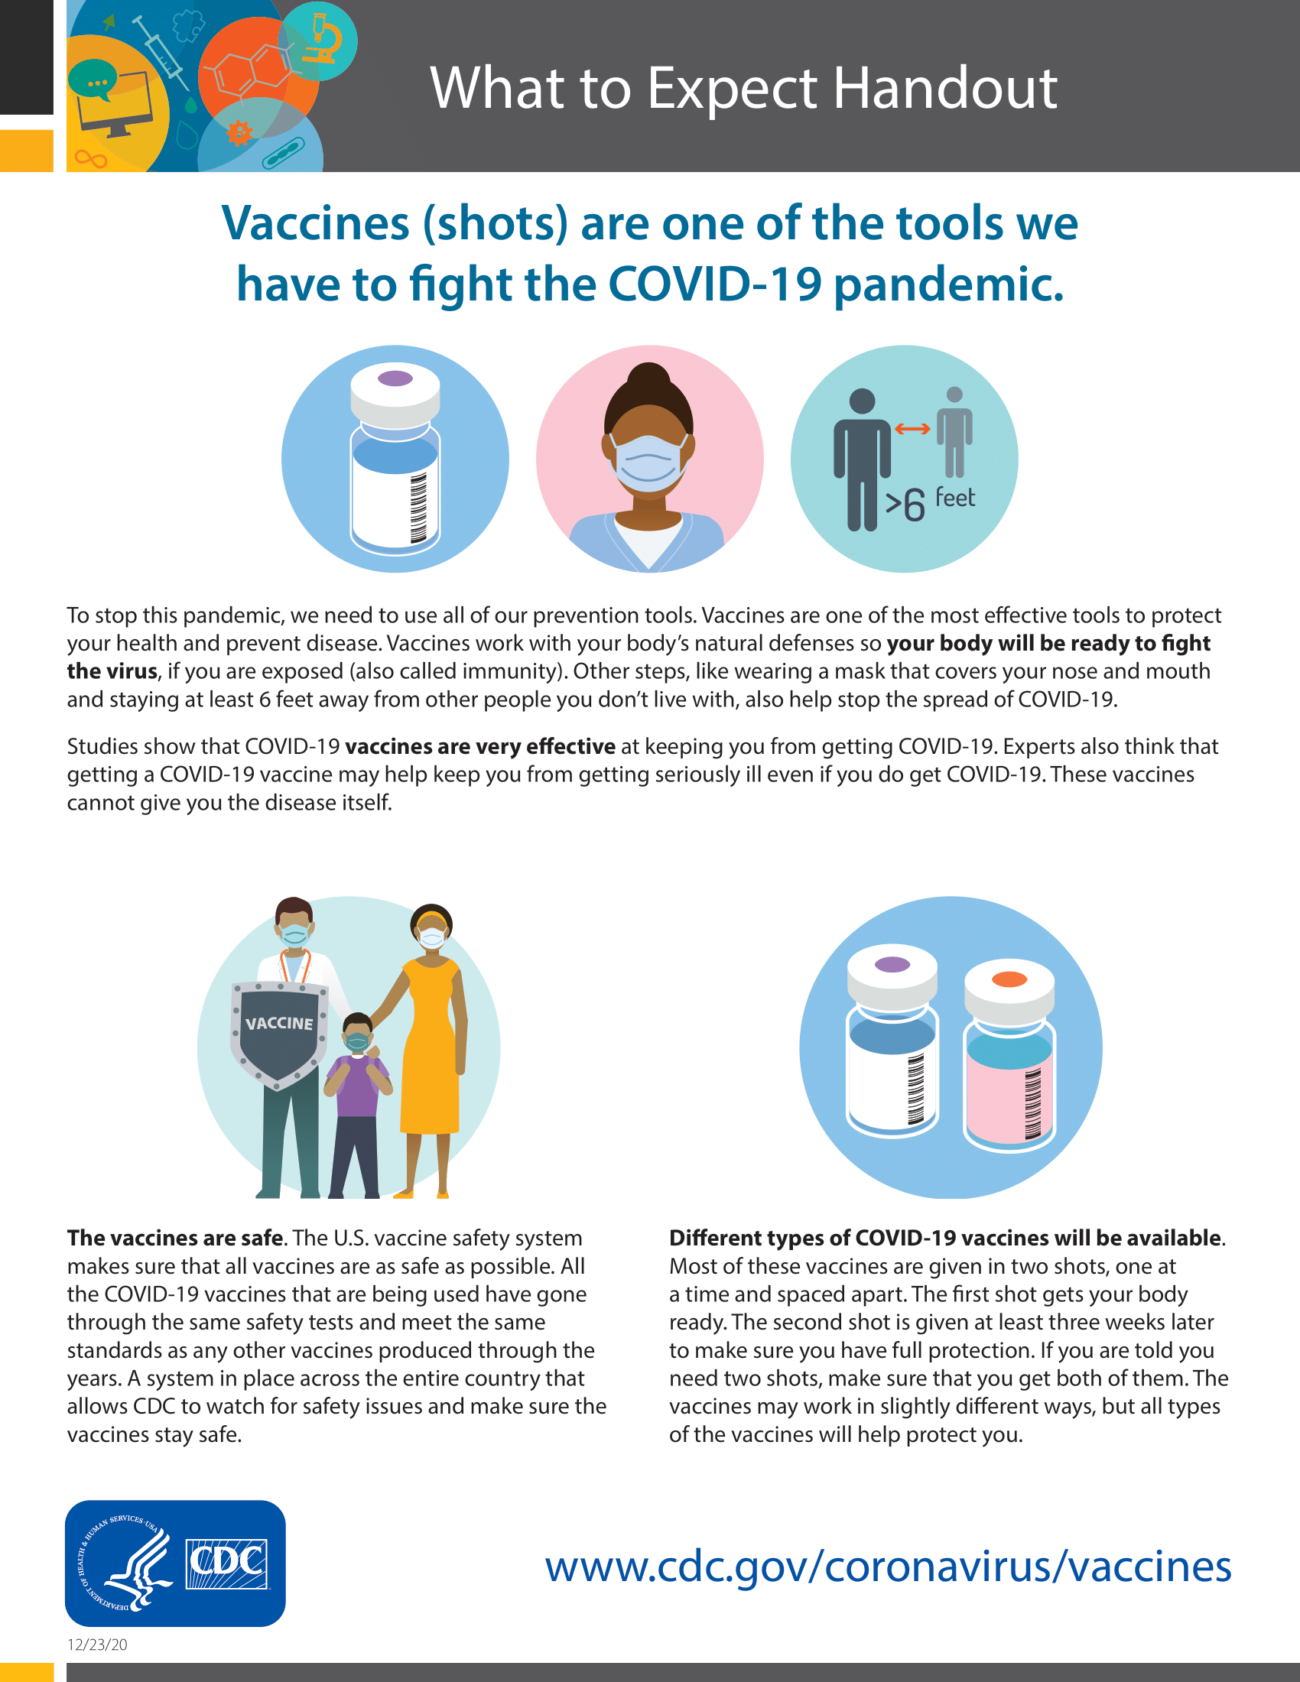
COVID-19 Vaccination: What to Expect Handout

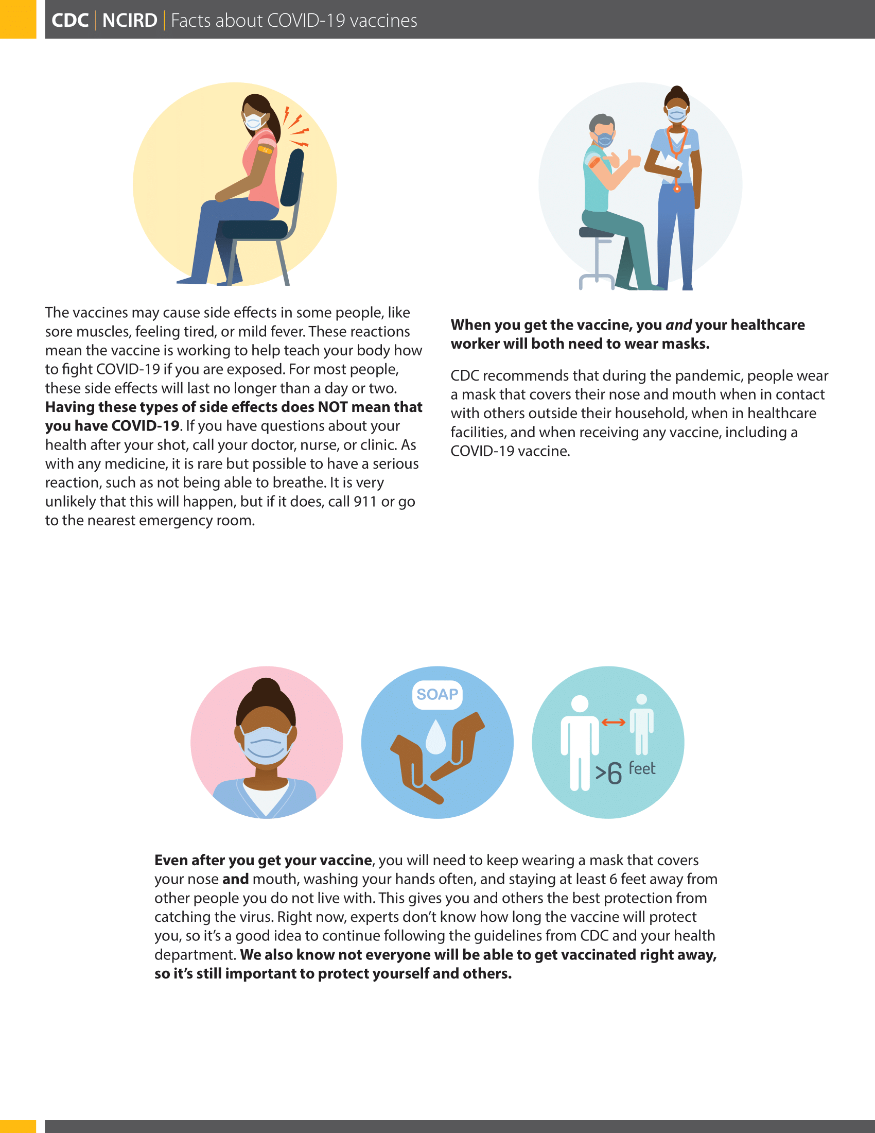

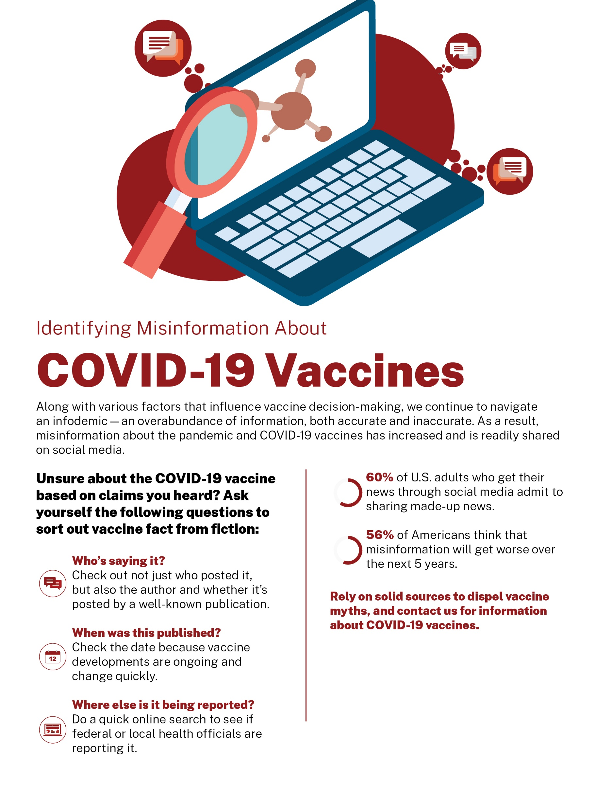
Identifying Misinformation About COVID-19 Vaccines - Infographic

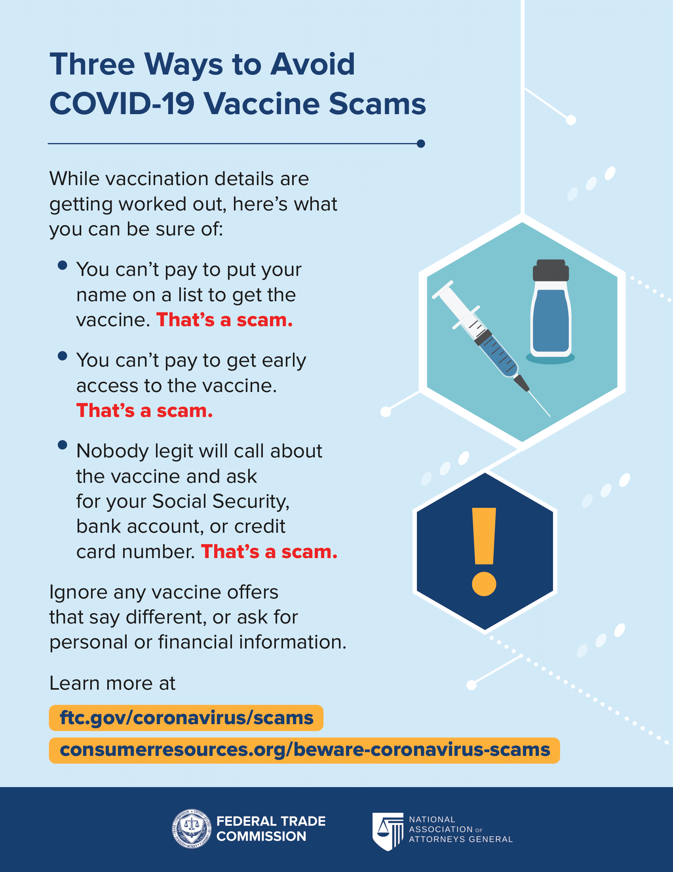
Three Ways to Avoid COVID-19 Vaccine Scams

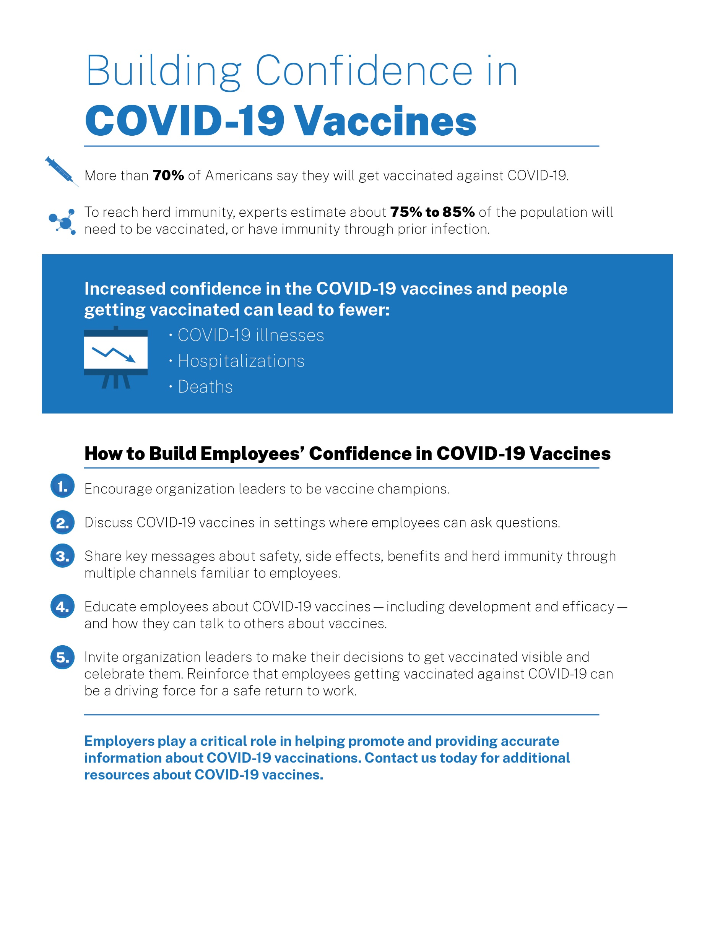
Building Confidence in COVID-19 Vaccines - Infographic
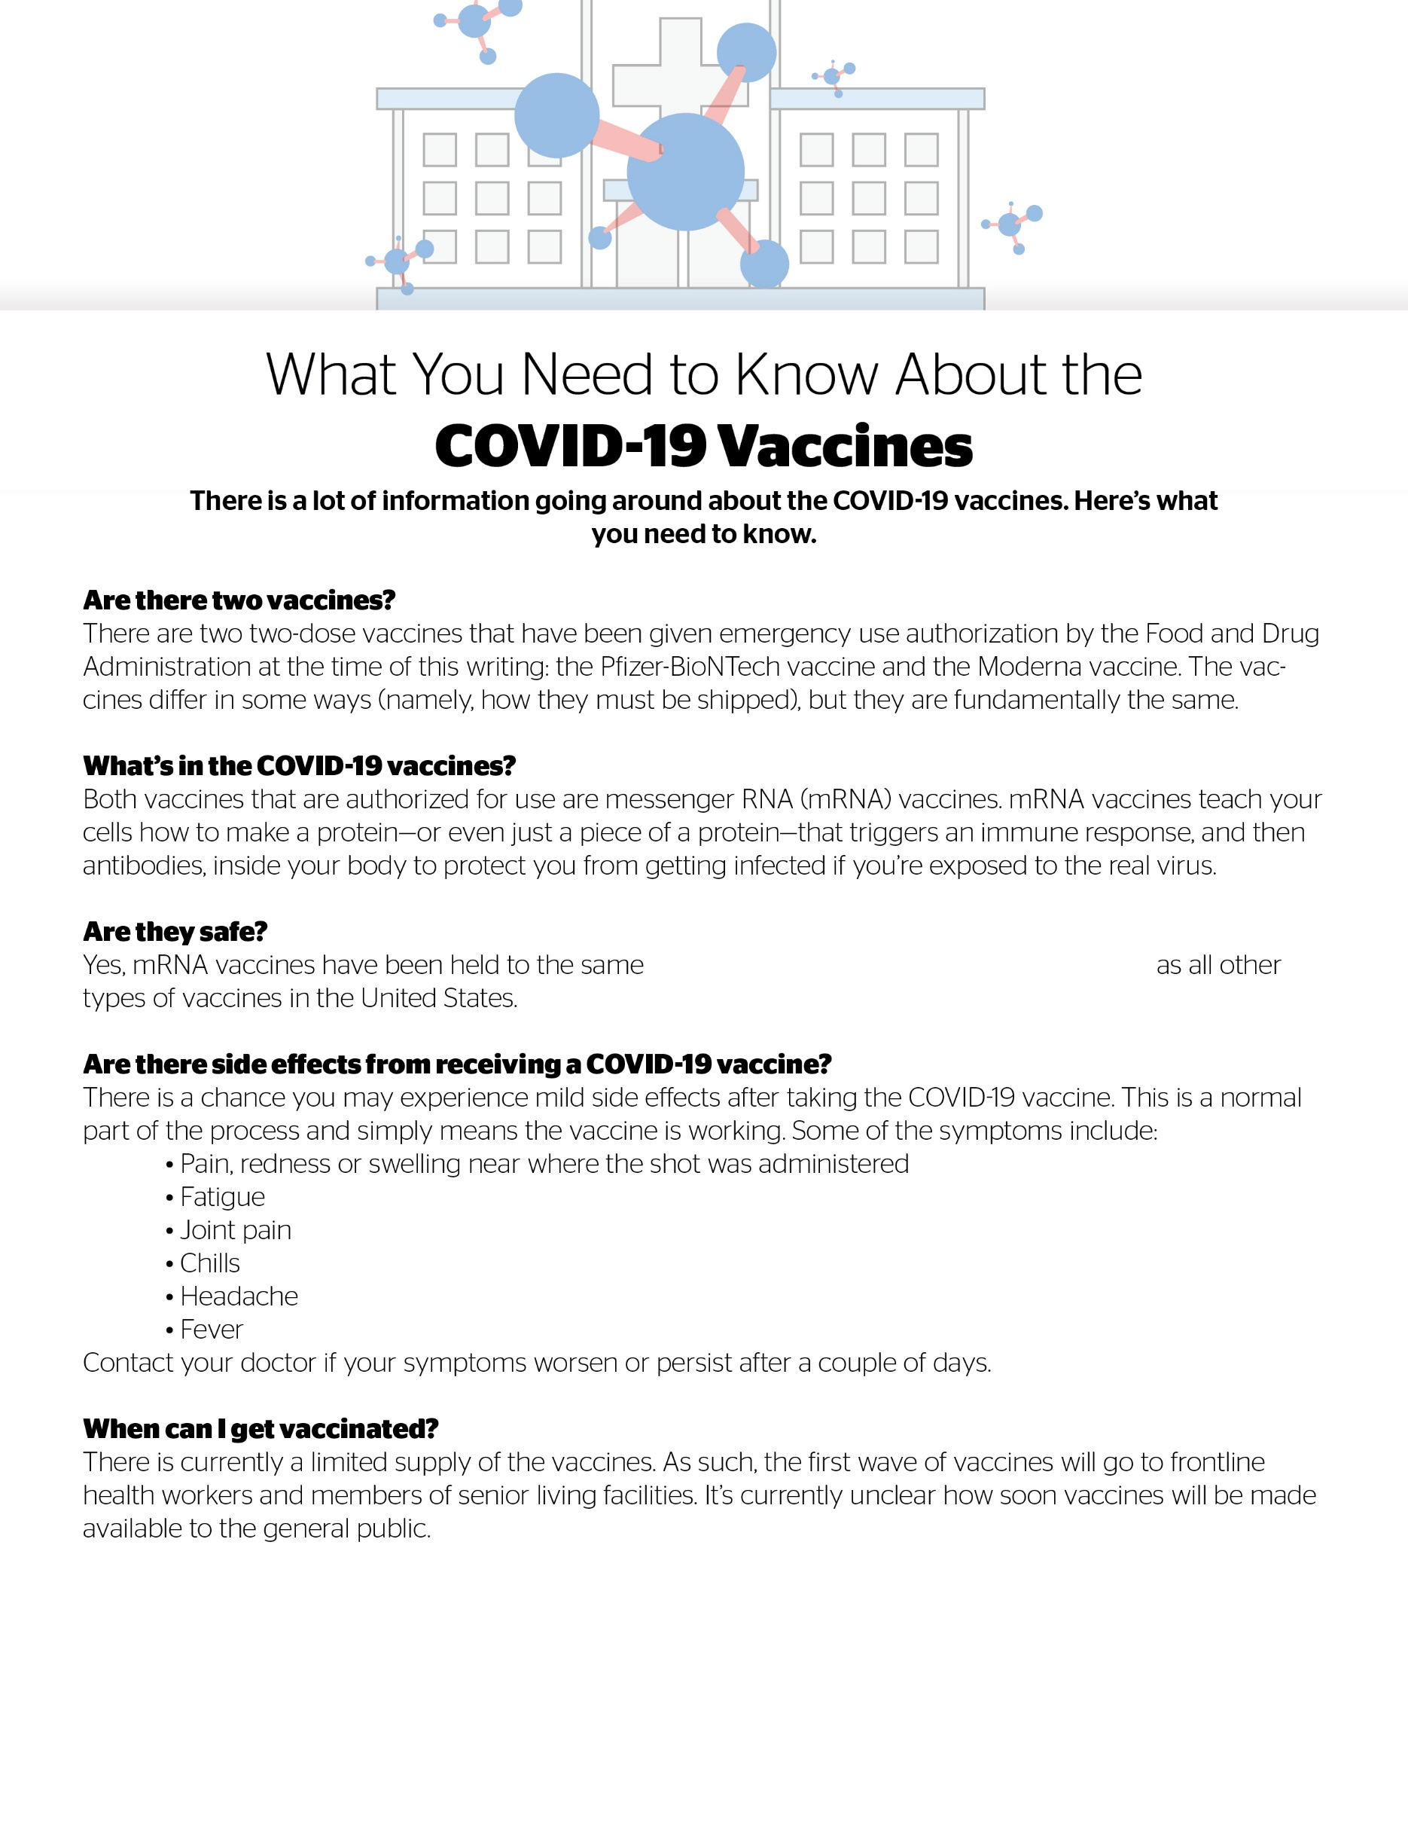

What You Need to Know About the COVID-19 Vaccines - Infographic

rigorous safety and effectiveness standards

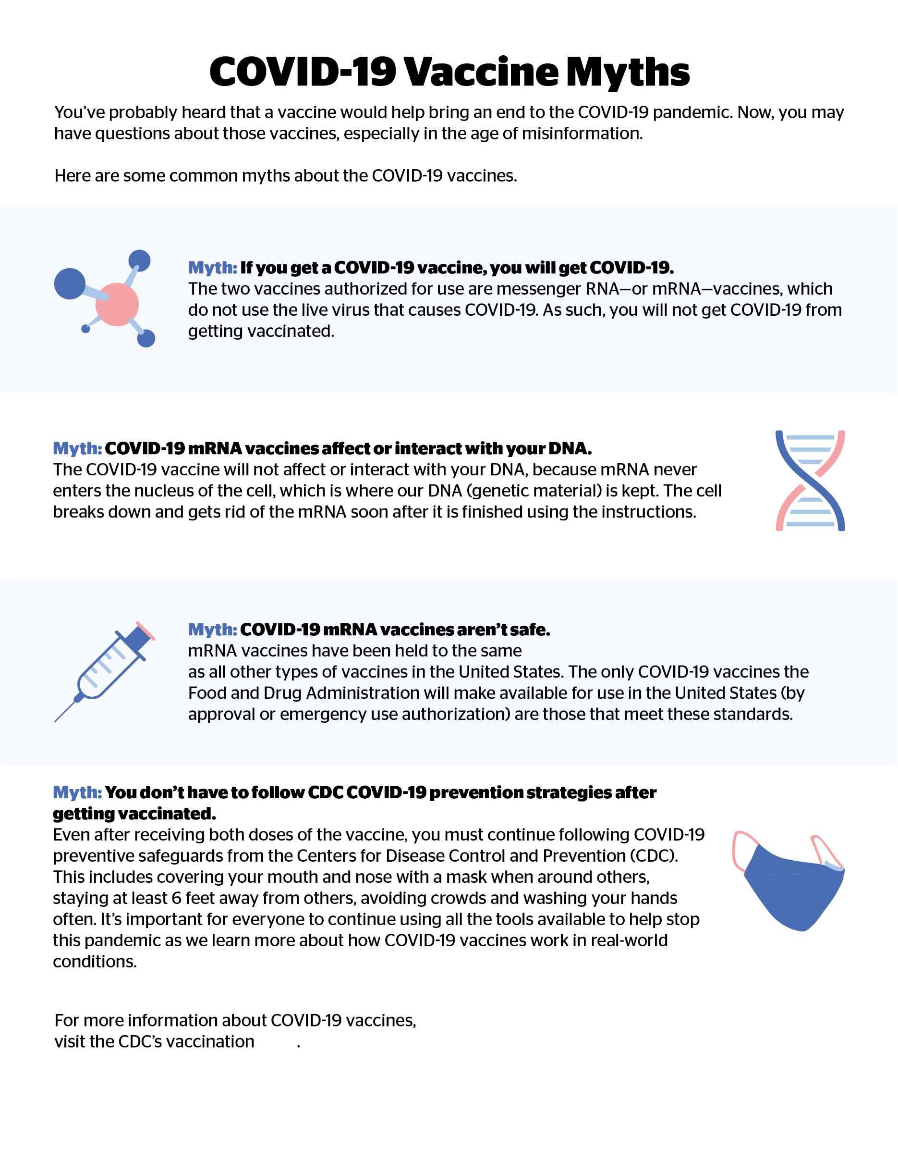
COVID-19 Vaccine Myths - Infographic

rigorous safety and effectiveness standards
page
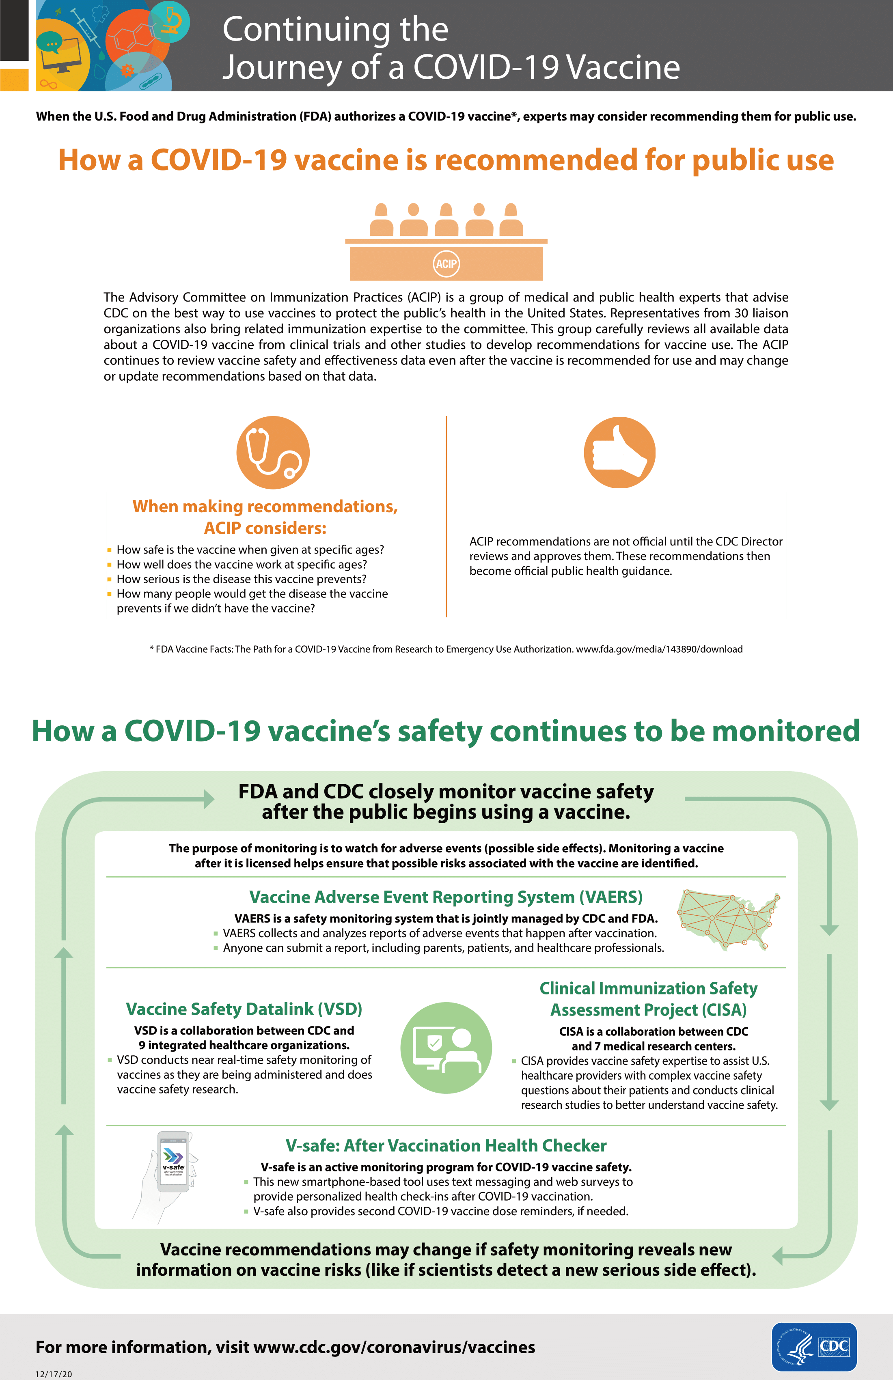

Continuing the Journey of a COVID-19 Vaccine - Poster

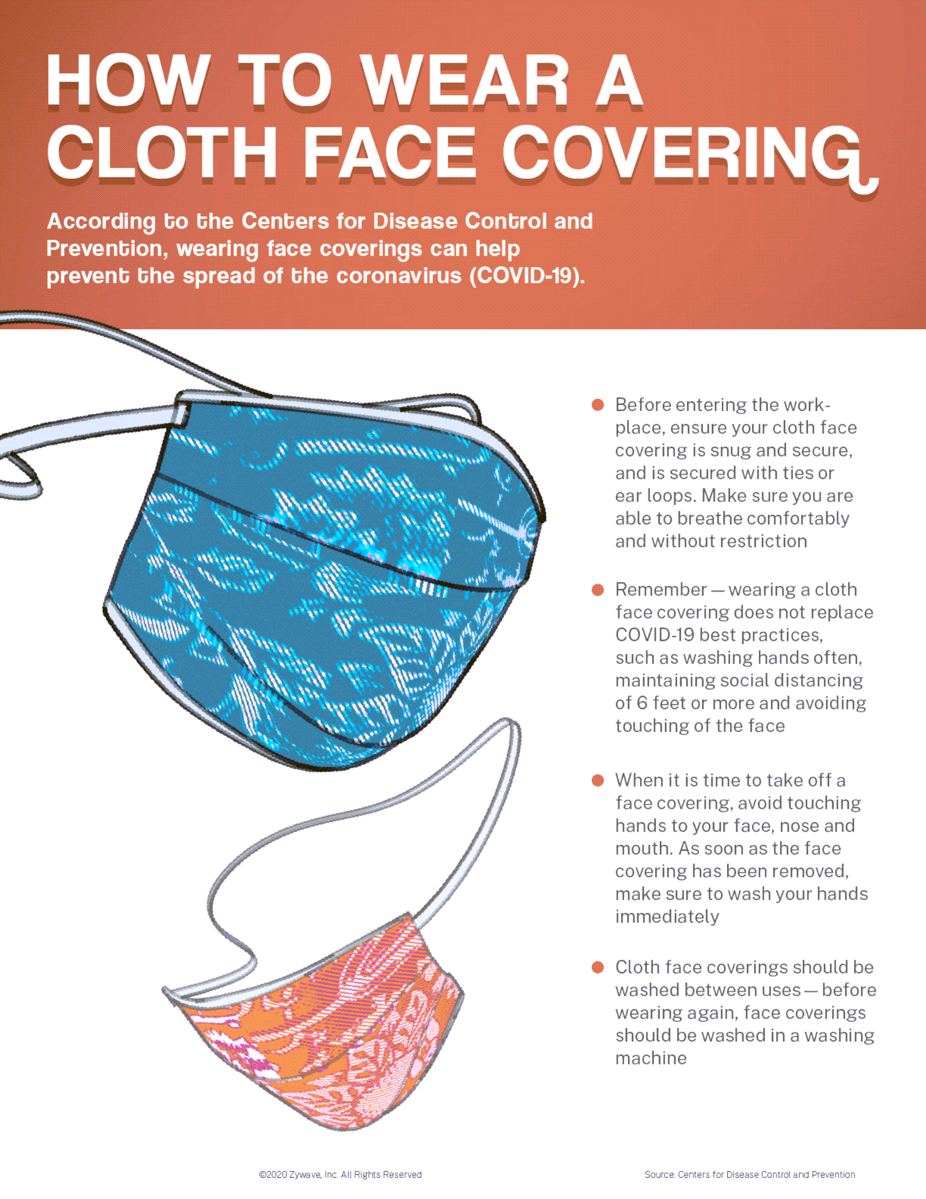
How to Wear a Face Covering Poster

